Disability 100 Findings report
Easier-to-read

Foreword

- Tortoise is a news company that looks at what is causing change in the world.

- The Valuable 500 are a group that are trying to draw more attention to disability.

- Tortoise and The Valuable 500 have partnered to create this report.

- Disability affects lots of people, but sometimes it is not given much attention.

- This report is telling people to pay more attention to disability in business.

Thank you for reading; we hope you find it interesting.


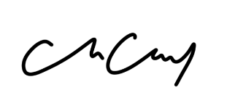
Caroline Casey
Founder of The Valuable 500


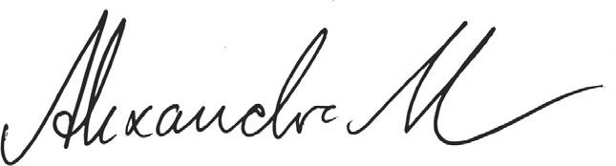
Alexandra Mousavizadeh
Director of Tortoise Intelligence

Representation

This research is based on reporting by the FTSE 100 and the things that they say about disability.

The key results are:

- The FTSE100 are 100 of the biggest companies in the UK.

- FTSE100 companies have ‘executives’ and ‘senior managers’ - they are the people who run the company.

- There are no ‘executives’ or ‘senior managers’ at FTSE100 companies who say that they have a disability.

- The report tells us that people with disabilities are not always represented at large companies.

- Not many of them even ‘disclose’ their disability when they are asked.

- ‘Disclose’ means that someone tells their company that they have a disability, even if it cannot be seen from the outside.

- The number of people employed by FTSE100 companies who are disabled has gone up at some of them.

- It is still low compared to the number of people in the UK who are disabled.
This chart shows the percentage of employees who are disabled at the companies in 2020, and the previous year in 2019.

Barclays had 8 in 100 representation in 2019, this went up to 14 in 100 in 2020.

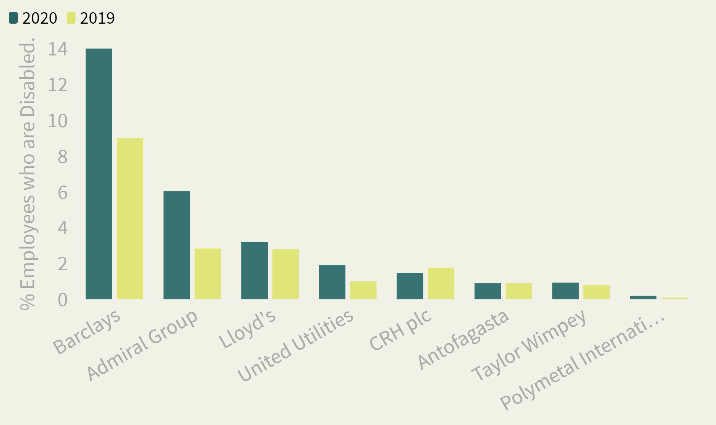

Methodology

Tortoise did the research by reading company reports, and asking the companies in the FTSE100 questions about them.

- ‘Executives’ and ‘senior managers’ doesn’t always mean the same thing at different companies so we have included a few other definitions.

- This report is correct based on information from 2020, which was the most recent we could access.

- 36 of the 100 companies gave Tortoise additional information to go in this report.

